**[DecisionHub](https://github.com/Abhishek-Mallick/Decision-Hub)**

**Problem Statement**

Develop a Rule Builder application "DecisionHub" that empowers Business Analysts to create, save,and visualize decision strategies. Provide a no-code rule writing experience and visual representation to test these rules in real-time and observe the calculations at each step.

**Overview**

Decision Hub is an application tailored to streamline the challenges encountered by Business Analysts in creating, storing, and visualizing decision strategies. Fueled by advanced language models (LLM Powered Generative AI) like Code Llama, BERT and innovative methodologies, this tool offers a user-friendly,seamless, no-code rule-writing experience tailored for analysts who may not have programming expertise.

Decision Hub is a comprehensive solution with distinct sections, each catering to specific needs:

Rule Builder for creation and visualization, Rule Management for database control, and Debugger for real-time testing. Elevate your decision-making processes with a user-centric approach that empowers analysts to navigate the complexities of rule crafting effortlessly.

**Rule Builder**

Effortlessly create, save, and visualize rules, intricately linked to the rules database. Intuitive design for a seamless rule-writing experience, ensuring accessibility for analysts with varying technical backgrounds.

**Rule Management**

Centralized control to add, modify and remove rules within the rules database. Simplifies rule governance, enabling swift adjustments to align decision strategies with evolving business requirements.

**Debugger**

Real-time testing functionality, facilitating the observation of calculations. Pinpoint and rectify errors efficiently, ensuring the reliability and accuracy of decision rules.

**Architectural Diagram**

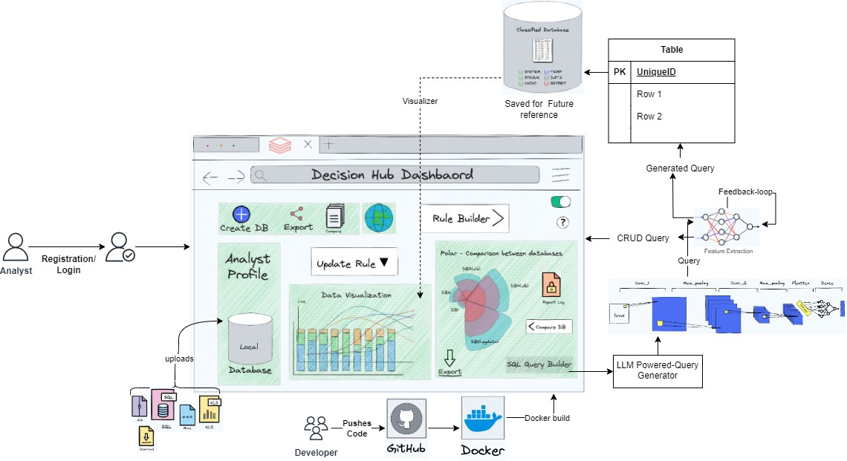

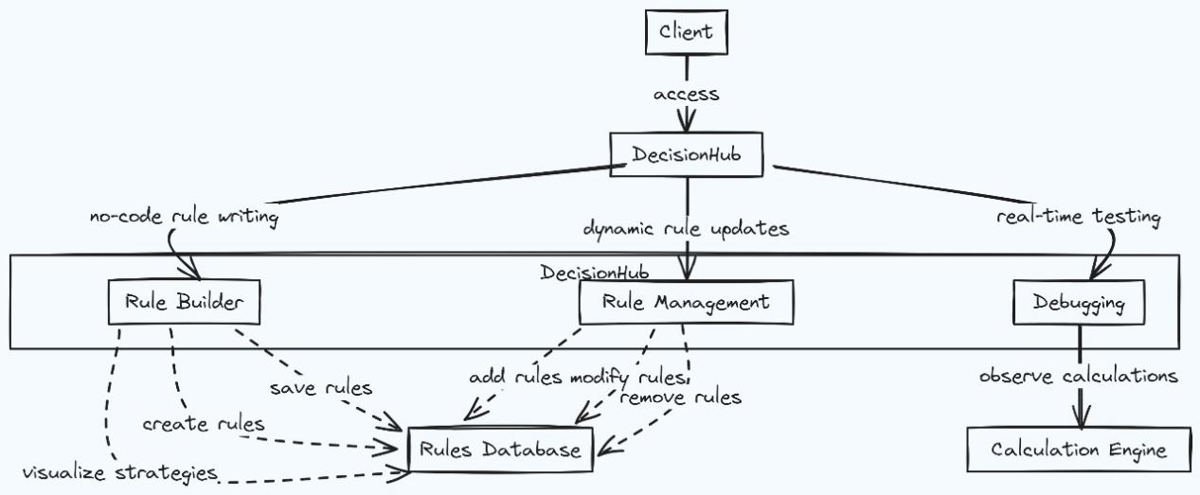**WireFrame Diagram**

**Solution**

**1. No-Code Rule-Writing Experience**

The Rule Builder eliminates the need for analysts to delve into programming languages or navigate complex technical interfaces. Instead, it offers an intuitive, no-code rule-writing experience, allowing analysts to focus solely on expressing their business knowledge without technology hindering their progress.

By the integration of the LLM (Large Language Model), the Rule Builder transforms plain English text into sophisticated queries. These queries, execute seamlessly across diverse platforms, extracting valuable data from databases. This integration enables analysts to convert business insights into actionable rules without the hindrance of technological complexities.

**2. Excel-Like Logic Support**

Recognizing that many Business Analysts are accustomed to working with tools like Excel or calculator-like logic, our application facilitates the writing of basic arithmetic expressions with conditional or comparison operators, these are then promptly converted into rules and queries powered by the LLM model. This ensures a seamless transition for analysts familiar with these widely-used platforms.

**3. Dynamic Rule Modification and Testing**

Addressing the challenge of frequently changing business rules, DecisionHub empowers analysts to quickly modify and test their decision strategies. With a user-friendly interface, analysts can make adjustments on-the-fly and observe real-time calculations, reducing the likelihood of errors and streamlining the adaptation process for evolving business requirements.

**4. Efficient Logic Checking for Thousands of Rules**

To tackle the complexity of managing thousands of rules, our application provides an easy-to-use mechanism for checking the logic of each portion of calculations rapidly. Leveraging LLM Powered Generative AI, analysts can run rules swiftly and double-click to identify potential issues or incorrect conditions within their decision strategies.

**Use-Case**

**Streamlined Rule Creation**: Business Analysts with no coding expertise can effortlessly create complex rules using Decision Hub's intuitive Rule Builder.

The application leverages LLM to convert plain English into sophisticated queries, eliminating the need for programming languages.

**Intuitive Rule Modification**: Analysts can dynamically modify decision rules within the Rule Management section, adapting to changing business requirements and regulations.The user-friendly interface ensures quick adjustments without relying on technical expertise.

**Visual Decision Strategies**: Rule Builder enables analysts to visualize decision strategies connected to the rules database, enhancing the comprehension of intricate rule relationships.Analysts can focus on expressing business knowledge, leaving the technical implementation to Decision Hub.

**No-Code Excel-Like Logic Support**: Decision Hub supports Excel-like logic, allowing analysts familiar with spreadsheet tools to express conditions in a comfortable environment.Basic arithmetic expressions seamlessly transform into rules and queries powered by the LLM model.

**Real-Time Testing with Debugger**: Analysts can test decision strategies in real-time using the Debugger, observing calculations and identifying errors promptly.

Provides a safe environment for experimentation and ensures the reliability of decision rules.

**Efficient Logic Checking for Scale**: Decision Hub's logic checking mechanism, backed by LLM Generative AI, efficiently handles thousands of rules.

Analysts can run rules swiftly and identify potential issues with a simple double-click, facilitating the management of extensive decision strategies.

**Adaptability to Regulatory Changes**: Decision Hub empowers analysts to swiftly adapt decision rules to comply with evolving regulatory requirements.

Dynamic rule modification capabilities ensure that businesses can stay compliant without extensive coding efforts.

**Increased Productivity and Accuracy**: By simplifying rule creation and modification, Decision Hub enhances the productivity of Business Analysts. Real-time testing and efficient logic checking contribute to the accuracy and reliability of decision strategies.

Decision Hub's diverse use cases cater to the specific needs of Business Analysts, enabling them to navigate the complexities of rule-making, decision strategies, and dynamic business environments without the necessity of coding expertise.

**Team Members**

**Abhishek Mallick** : 21051706

<https://www.linkedin.com/in/abhishek-mallick09/>

**Deepraj Bera** : 21051302

<https://www.linkedin.com/in/deepraj-bera-b64996231/>

**Harshit Mania** : 21051398

<https://www.linkedin.com/in/harshit-mania-720bbb236/>

**Aman Chaurasia** : 21051370

<https://www.linkedin.com/in/chaurasia-aman/>

[Github](https://github.com/Abhishek-Mallick/Decision-Hub)

[Presentation](https://docs.google.com/presentation/d/1P0mRTmXNhRRIQcidHsdcvi88HU9BLwPa/edit?usp=sharing&ouid=111461883961008010128&rtpof=true&sd=true)